# Manual of Plugin:List Products and Vector

### Plugin position:

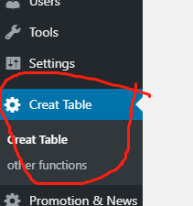

### Add Products to web page:

1. Click ‘Add’

**Picture A**

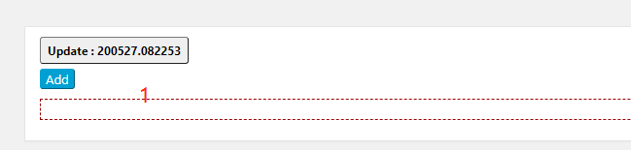

1. Select datetable
2. Write title(If left blank,it will be named automatically in the format of YY MM DD, HHM s
3. Choose the products
4. Fill the link in this input field. Leave blank if it do not has a link. Double click to use the default value.
5. Save it.

**Picture B**

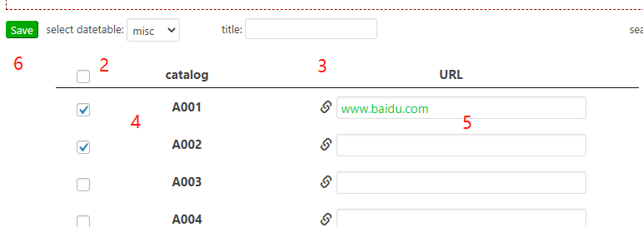

1. Use this red text in the post.Copy it and paste it.(See picture C and picture D). See the result in Picture E

**Picture C**

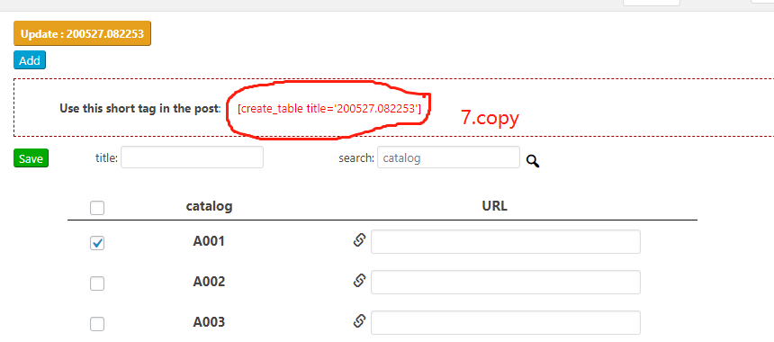

**Picture D**

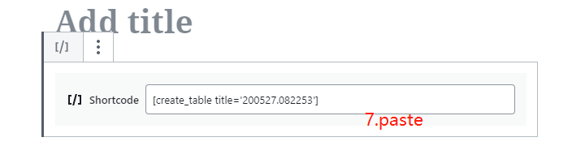

**Picture E**

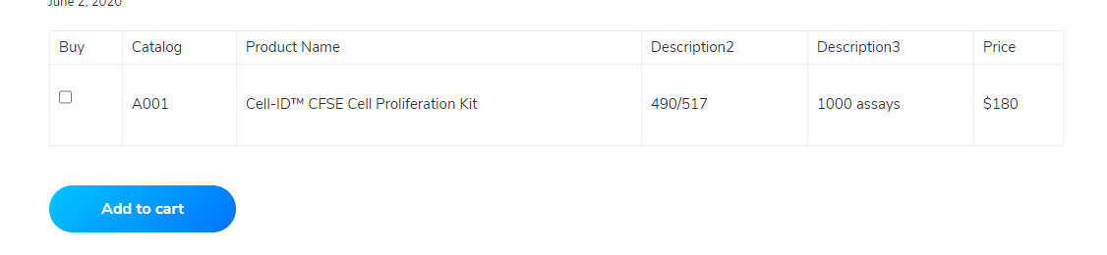

1. Search label .
2. Search product.

**Picture F**

